Packing instructions

# LLTF into PELI 1610 Case.

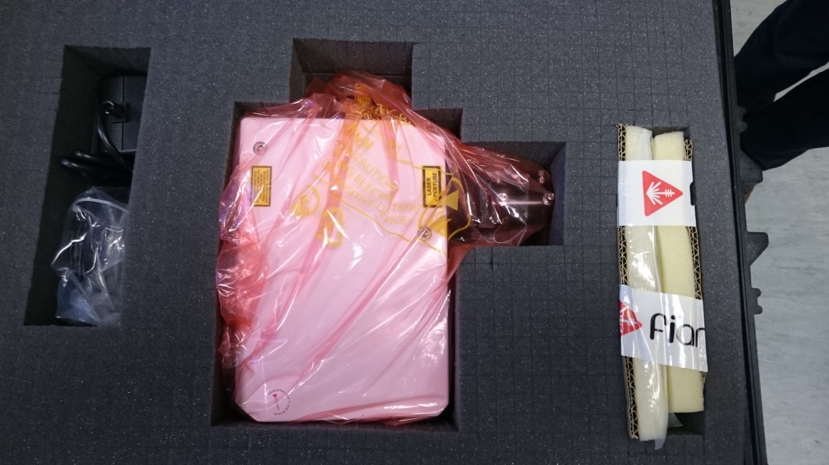

ACCESSORIES

FDS

LLTF IN ANTI-STATIC BAG

**Packing the components:**

1. **Carefully remove the top layer of foam only, before packing any items.**
2. **Ensure the LLTF is wrapped in an anti-static bag and place in the designated void orientated as in the picture above.**
3. **Carefully replace the top layer of foam after inserting the LLTF.**
4. **Place the accessories box in the accessory void**
5. **Insert the cardboard FDS holder(s) in the designated slot.**
6. **Affix the relevant paperwork to the components.**
7. **Place a copy of these packing instructions on top of the unit before closing the case.**